**Industry Auto Parts Manufacturing in Canada**

Glenda Salcedo López (2405338)

Mariano Rivera Ramos (2408910)

Maricela González Castillo (2410742)

Melany Natalia Bartha Cordova (2406936)

Yaiselin Estefany Zapara Piñate (2403660)

Zulema Torres Rodrigo (2352688)

University Canada West

Operations Management OPMT620 (HBD-SPRING25-21)

Jafar Heydari

June 15, 2025

**Abstract**

The report examines the operational performance of Linamar Corporation, a leading Canadian industrial equipment and auto parts manufacturer. The company operates a vertical supply chain model with 75 plants in 19 countries, which has allowed it to operate with low logistics costs, in contrast to the industry average, while achieving consistent revenue growth, surpassing the industry average.

This report also identifies flaws in Linamar's inventory management and labor productivity. In 2023, the inventory turnover ratio was below the industry standard. Although labor productivity has improved over the past five years, revenue per employee remains below the industry average. These flaws affect the effectiveness of working capital and reflect an efficiency gap.

Linamar has a strong position in the industry but must address the challenges of its operations. To this end, it recommends using demand forecasting models and implementing ABC inventory classification. These operational contributions will help Linamar maintain its global competitiveness, reduce inventory, and improve synchronization between production and demand.

**Industry Auto Parts Manufacturing in Canada**

1. **General Industry Overview**

**1.1 Industry Overview**

Auto parts manufacturing is a subsegment of the automotive industry, and it manufactures components for motor vehicles, such as engines, transmissions, brakes, airbags, heating systems, filtration devices, etc. The exhaust system is the main source of revenue for auto parts manufacturers. According to Guirguis (2024), market segmentation is based on revenue by market type: Automakers with $4.1 billion (51.3%), Wholesalers and distributors with $2.7 billion (34.6%), Aftermarkets with $1.0 billion (12.9%), and Other with $95.0 million (1.2%) in 2024.

Recently, in 2022 and 2023, auto parts manufacturers in Canada experienced stagnant profits due to the contraction in revenue during the COVID-19 pandemic and rising prices for inputs such as steel and semiconductors due to the war between Russia and Ukraine. Fortunately for the industry, however, economic stability has been reestablished, generating greater demand for new and used cars, which, through repairs, have also boosted demand for auto parts. According to Guirguis (2024), Manufacturers revenues had increased at an expected compound annual growth rate of 1.2% to $7.9 billion over the current period, including a 1.9% increase in 2024, when profits reached 8.7%."

For the coming years, auto parts manufacturers in Canada are expected to experience a solid recovery, given certain market conditions, such as the new market niche in electric and autonomous vehicle parts, the sale of spare parts due to the average age of vehicles, and macroeconomic factors. A stable economy and moderate inflation will boost consumer confidence and increase auto sales, while the depreciation of the Canadian dollar will boost exports. By 2029, auto parts manufacturers' revenue is expected to recover at a CAGR of 1.4% to $8.5 billion, with profits of up to 8.7%, according to Guirguis (2024).

**1.2 Linamar Corporation**

Linamar Corporation is a highly engineered products manufacturing company divided into two major operating segments, according to Linamar (2024): the Industrial segment (products for aerial work platforms and Agriculture portfolio) and the Mobility segment, which specializes in products for the electric and traditional vehicle markets, such as propulsion systems, structural and chassis components, energy storage, and power generation. Mobility operates vertically through three regional groups: North America, Europe, and Asia Pacific, combining expertise in light metal casting, forging, machining, and assembly, according to Linamar (2024). The company's operations are based on an international network of 75 plants located in 19 countries, which allows it to maintain precise logistics based on deliveries coordinated directly with its customers' production lines,

In 2024, Linamar Corporation closed the year with a significant increase in its revenue of over $10 billion, showing an increase compared to $9.7 billion in 2023, which occurred thanks to market consolidation and the signing of new contracts, according to Linamar Corporation (2024). Despite Linamar's significant growth, other companies in the sector directly compete for leadership positions, such as Magna International and Martinrea. Furthermore, all industrial activities must comply with strict regulations imposed by entities such as Transport Canada and Environment and Climate Change Canada and technical standards such as IATF 16949 certification (NFS, 2025). One of the most anticipated projects for 2025 is opening a new foundry in Welland, ON, and strengthening its position in the industry, which will mark the transition toward sustainable manufacturing.

According to Linamar Corporation (2022), Linamar experienced a production delay due to semiconductor shortages, rising raw material prices, and logistical challenges, further complicating supply. In this sense, it is important to review supply chain, as well as sourcing methods, in order to avoid risks and improve the flow of goods, thus, Linamar will reduce costs, increase competitiveness, and improve efficiency, which ultimately translates into customer loyalty and high levels of satisfaction.

**2. Data presentation**

Linamar Corporation is a major Canadian manufacturer company focused in the automotive and industrial segments which includes precision machining, mobility systems and industrial equipment. The firm provides powertrain, chassis and structural parts and systems to worldwide OEMs such as Ford, Toyota, General Motors.

Linamar has a complex and vertically integrated supply chain which encompasses procurement of raw materials, advanced manufacturing, assembly and global distribution. They have operations in 19 countries and their supply chain strategy has been to focus on efficiency and automation as well as just-in-time delivery. We further examine the supply chain performance of Linamar based on leading operational measurement and industry averages below.

**2.1 Supply Chain KPIs**

**Figure 1**

*Inventory Turnover Ratio*

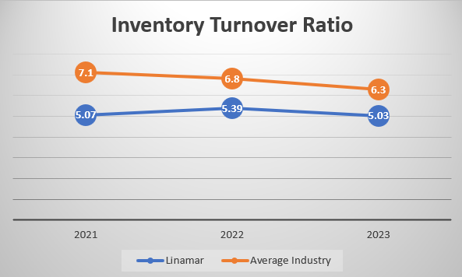

*Note.* The graph was created based on information collected from Linamar's annual reports from 2021 to 2024 and industry data from financial benchmarks of IBISWorld.

Figure 1 shows Linamar's inventory turnover compared to auto parts manufacturing in the Canadian industry (Guirguis, 2024). It can be seen that in 2021, 2022, and 2023, Linamar is below the industry. It means that its inventories are held longer or have a slower inventory turnover than the industry, which could lead to excess stock. This could be due to lower logistics efficiency; it could also be due to complex production.

According to Linamar (2024), the company is dedicated to two segments: Mobility, which is about the manufacturing of vehicle components, and Industrial, which focuses on agricultural machinery. By operating in two segments, they may need a variety of products in inventory to avoid delays due to the lack of components necessary for manufacturing.

**Figure 2**

*Logistic Costs (% Revenue)*

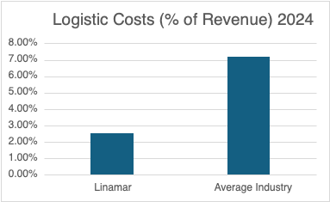

*Note.* The graph was created based on information collected from Linamar's annual reports from 2024 and industry data from IBISWorld.

Figure 2 shows the logistics costs of Linamar from 2024 compared to the average for the auto parts manufacturing industry in Canada, as reported by IBISWorld 2024. While the industry consistently maintains logistics costs around 7.2% of total revenue (Guirguis, 2024), Linamar’s costs remain significantly lower with 2.54% which is significantly lower.

This variation is given the fact that Linamar has been extremely logical in its integrated supply, its strategic location as well as its automated production systems.

Overall, the difference between Linamar and the industry indicates that the company is performing well by minimizing logistics expenses relative to revenues which improves operating margin and cost competitiveness.

**Figure 3**

*Revenue per employee*

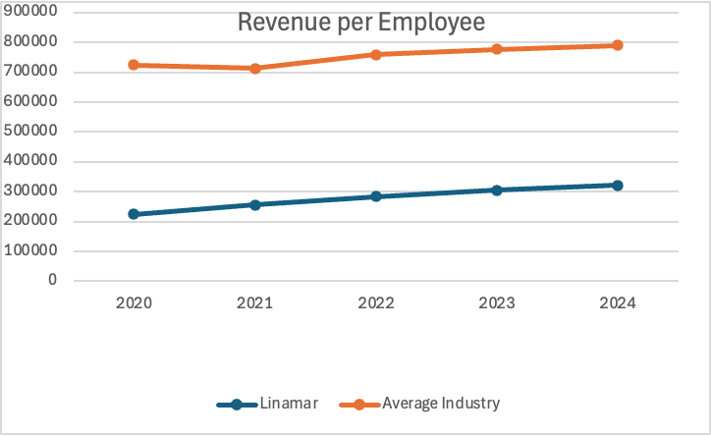

*Note.* The graph was created based on information collected from Linamar's annual reports from 2020 to 2024 and industry data from IBISWorld.

In Figure 3, revenue yield per employee has been analyzed and it measures the average generated revenue by each employee in one year. This measure shows us overall labor productivity and operating efficiency.

Between 2020 and 2024, Linamar expanded this measure in five years, which denotes that the company demonstrates stable improvements, where it uses labor to produce revenues.

However, when compared to the industry average, Linamar is below the industry average. This difference indicates that they can improve this indicator.

**Figure 4**

*Revenue Trend*

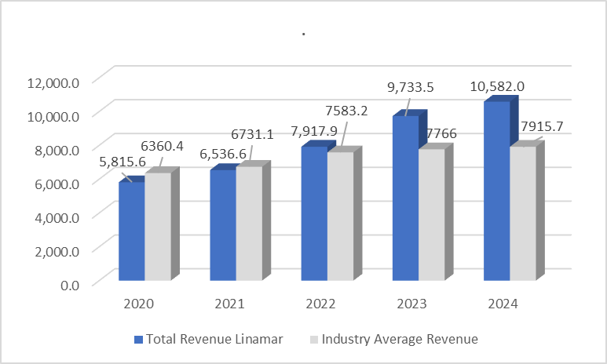

*Note.* The graph was created based on information collected from Linamar's annual reports from 2021 to 2024 and industry data from the financial benchmarks section of IBISWorld.

As shown in Figure 4, Linamar's revenue growth is steady from 2020 to 2024, with an 82% increase between those years. However, the industry average revenue growth is lower, with only 24.5% growth from 2020 to 2024, according to information obtained from Guirguis (2024).

According to Linamar's annual report, its revenue increased in 2023 due to the acquisition of Bourgault Industries, which focuses on the manufacture of industrial agricultural machinery. Therefore, Linamar must focus on supply chain planning for both the Mobility and Industrial subsectors to meet deliveries.

1. **Data Analysis**

**3.1 Trends and Key Findings**

Considering the data collected, Linamar Corporation has shown consistent revenue growth, reaching approximately $10.6 billion in 2024 (Figure 4). In addition, their logistics cost reflects that they are lower and more efficient than the industry average, with logistics expenses only accounting for 2.54% of revenue, in contrast to the industry average of 7.2% (Figure 2). However, the data suggest that Linamar is facing operational issues related to low inventory turnover.

From 2021 to 2023, Linamar’s inventory turnover ratio remained below industry standards, getting 5.03 vs. 6.3 of average industry in 2023, indicating below average turnover of stock (Figure 1). This suggests excess stock, which runs counter to the foundational logic of Just-in-Time (JIT) principles. This will negatively impact working capital, responsiveness, and flexibility, especially in a volatile global market, which includes shifts towards electric vehicles (EVs) and supply chain disruptions.

**3.2 Main Operational Challenge**

The most important operational challenge identified in Linamar is regarding the inefficient inventory turnover, which undermines its Just-in-Time (JIT) logistics strategy. Its slower inventory turnover represents a bottleneck in capital efficiency and supply chain responsiveness. This inventory turnover ratio could reflect an inadequate synchronization between demand forecasting and production.

**3.3 Data Analysis and Application of OM Tools**

Measures of the performance of the effectiveness of the inventory management

***Inventory turnover***

Inventory turnover= $\frac{Cost of Goods Sold (COGS)}{Average Inventory}=\frac{8.410,70}{1.673}=5,03$

Cost of Goods Sold (COGS) year 2023= CAD 8,410.8 million

Average inventory year 2023= CAD 1,673.0 million

Analyzing the data of Linamar, it is possible to calculate the turnover inventory for the year 2023, which is 5,03 times per year, being lower than the industry standard (6,03 times per year), which implies a less efficient use of inventories or forecasting issues.

***Just-in-Time and Lean practices***

Logistic cost %= $\frac{Logistics Cost }{Total Revenue }X 100=\frac{269,145}{10,582,022}X 100=2,54\%$

Year 2024

Logistics cost= 269,145

Total revenue= 10,582,022

This calculation indicates a cost ratio of 2.54% for the year 2024, which is below the Canadian auto parts manufacturing industry average of 7.2%, reflecting a high efficiency in managing logistics costs and it is related to lean manufacturing principles, such as minimizing non-value-adding activities and aligning production with customer demand

JIT is supported by Linamar’s global network of 75 manufacturing plants across 19 countries (Linamar Corporation, 2024), which allows to the company to reduce lead times and minimize excess stock by producing and delivering only what is needed, when it is needed.

***Productivity***

Productivity= Outputs/Inputs

Partial productivity= Output/Single input

Labour productivity= Output / Labour Input

Revenue 2024= 10,582.02 million CAD

Labour input: 33,000 employees

$$Labour Productivity=\frac{Revenue }{Total Employees}=\frac{10,582,020,000}{33,000}=320,667.88$$

In the period 2024, the amount of revenue per employee was CAD 320,667, indicating an increase above 40% since 2020, which means some improvements in the internal efficiency. However, if we compare with the industry average, the labour productivity is below of the benchmark of CAD 470,249, highlighting a productivity gap of nearly CAD 150,000 per employee (Figure 3), which suggests that Linamar still need to improve its workforce efficiency in comparison to the industry average.

***Suppliers analysis and evaluation***

Linamar competes in an environment where Original Equipment Manufacturers (OEMs) are trimming their supplier list and giving out contracts based on more than just cost (Linamar Corporation, 2024). Factors like delivery performance, quality, and technology capabilities are critical for Linamar.

This trend empathizes the importance of supplier relationship management and strategic sourcing in operations management. Although some of its competitors are better resourced, Linamar is able to compete through reliability and efficiency because of its vertically integrated structure and broad capabilities.

**3.4 Cost of Capital Tied to Inventory**

From the above analysis we have seen that Linamar’s inventory turnover reveals operational inefficiencies, but also a significant financial impact tied working capital. With an inventory turnover ratio of 5.03 in 2023 compared to the industry benchmarrk of 6.3, Linamar is holding more inventory than necessary, then by using the following information of Linamar.

Using Linamar’s 2023 figures:

COGS: 8,410 Million CAD

Average Inventory: 1,673 Million CAD

$$Inv. Turnover= \frac{COGS}{Average Inv.}⇒ Average Inv= \frac{COGS}{Inv. Turnover}$$

We can see that if Linamar were to be in the inventory turnover ratio values of the industry average of 6.3, this would had meant an average inventory in 2023 of just 1,335 million CAD.

$$Avergage Inv=\frac{8,410 million CAD}{6.3}=1,335 million CAD$$

So if we compare Linamar’s average inventory in 2023 of 1,673 million CAD, which the average inventory that would have had if it reached the industry average of 6.3 in its inventory turnover ratio, Linamar would have had an average inventory of 1,335 million CAD, so we can see that Linamar has an excess capital hold up in inventory of 338 million CAD. This hold up capital could have been used in other investments of Linamar, as is the case of R&D or technological upgrades as IA services. Which means a constraint in Linamar’s financial flexibility.

1. **Recommendations**

To address the issue of low inventory turnover ratio, Linamar could implement a demand forecasting approach combined with inventory segmentation strategies. Considering that Linamar operates in both the Mobility and Industrial sectors, the company should apply exponential smoothing to forecast demand for stable, high-volume components and causal models for parts affected by external factors like EV market expansion or supply chain instability. Through the implementation of these techniques, the company can reduce forecast errors and align production more closely with real customer needs, to reduce excess stock.

In addition, by taking into consideration Linamar’s dual segments, and to address Linamar’s low inventory turnover, they should apply ABC classification to categorize its inventory, to apply effective strategies (Stevenson et al., 2021). This would allow Linamar to group items based on their contribution to the total inventory values, “A” for high-value items, “B” for moderate-value, and “C” for low-value where simple restock systems as min, max inventory is enough. This would bring more structure and control to its to help align with the company’s overall complexity, improving efficiency and flexibility.

Additionally, Linamar must focus on the productivity of its workforce since the difference of CAD 150,000 per employee shows a low efficiency compared to the industry. Linamar can improve the productivity of its employees through standardized work and cross-training (Stevenson et al., 2021). Cross-training is useful for enhancing employee flexibility, which means training them to perform different tasks, reducing downtime, and increasing motivation. Also, work standardization reduces human errors, increasing quality . Linamar should take labor productivity measurements from time to time, such as the "Revenue per employee" test we made, to see if efficiency is really improving or if adjustments need to be made.

Finally, according to the KPI in logistics costs, we suggest that Linamar should strengthen the competitive edge through the investments in the enabling technologies in logistics like the real-time freight tracking, automated warehouse management, and route optimization programs. Linamar can always grow by continuously innovating, even though its current results of logistics costs amounting to 2.54% of revenue (vs. 7.2 % industry average) are already better than the industry. The solutions not only would assist in maintaining the low cost of logistics but would also increase the responsiveness and traceability of the supply chain, which would be consistent with Lean principles and customer satisfaction.

**References**

Guirguis, J. (2024, September). *Auto Parts Manufacturing in Canada. Canada 33639CA*. IBISWorld. <https://my.ibisworld.com/ca/en/industry/33639CA/at-a-glance>

Linamar. (2024). *Linamar.* <https://www.linamar.com>

Linamar Corporation. (2020). *Annual report 2020*. <https://www.linamar.com/wp-content/uploads/2021/08/Annual-Report-2020-March-29-FINAL.pdf>

Linamar Corporation. (2021). *Annual report 2021*. <https://www.linamar.com/wp-content/uploads/2022/03/2021-Annual-Report-FINAL.pdf>

Linamar Corporation. (2022). *Annual report 2022*. <https://www.linamar.com/wp-content/uploads/2023/03/2022-Annual-Report_Final-.pdf>

Linamar Corporation. (2023). *Annual report 2023*. <https://www.linamar.com/wp-content/uploads/2024/03/2023-Annual-Report_Final.pdf>

Linamar Corporation. (2024). *Annual report 2024*. <https://www.linamar.com/wp-content/uploads/2025/03/Annual-Report-2024-Final.pdf>

NFS. (2025). IATF 16949 Automotive Quality Management System Certification. <https://www.nsf.org/ca/en/management-systems/quality-management/iatf-16949-2016>

Stevenson, W., Hojati, M., Cao, J., Mottaghi, H., Bakhtiari, B. (2021). *Operations Management,* 7th Canadian Edition, McGraw Hill.

**Appendix**

Appendix A: Inventory Turnover Ratio Calculations

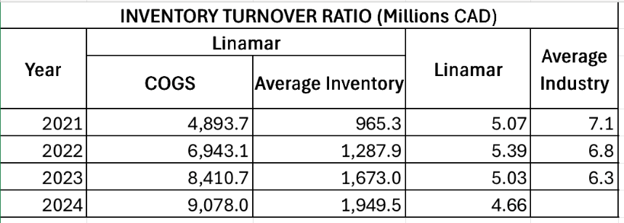

Appendix B: Logistic Costs (% Revenue) Calculations

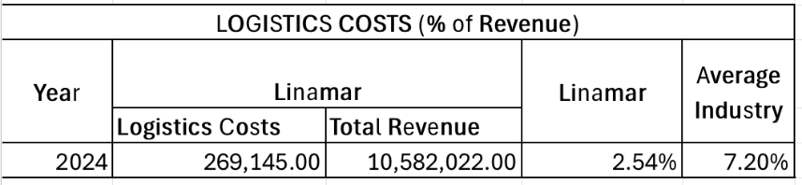

Appendix C: Revenue per employee Calculations

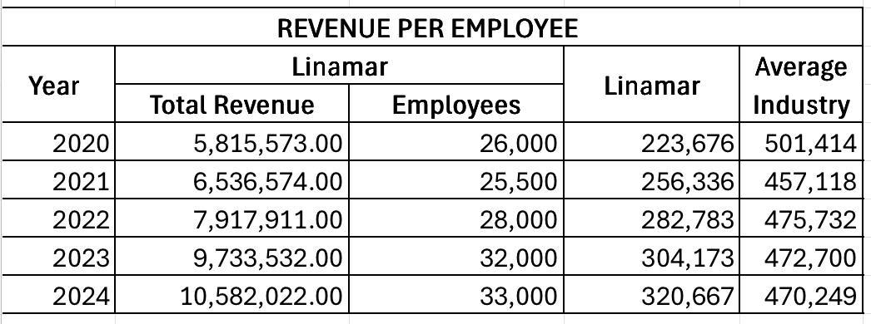

Appendix D: Revenue Trends Calculations

